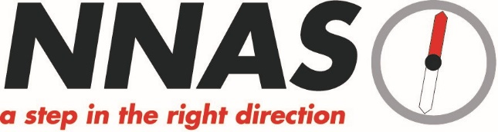

NNAS Bronze Navigation Award Syllabus

- Navigate using a variety of maps and scales.
- Use 4 and 6 figure grid references with worded descriptions to define the position of a map feature and to locate a feature on the ground.
- Orientate the map using handrails, obvious point features and major landforms.
- Use linear features (e.g. paths, tracks, clear boundaries) as handrails in simple navigation exercises.
- Relate prominent landforms such as large hills and valleys to corresponding contour information on the map.
- Orientate the map by aligning a compass needle against grid north and be aware that magnetic variation causes an inaccuracy.
- Use an orientated map to confirm direction of travel.
- Use clearly identifiable features to confirm position along the route and to recognise when the target has been overshot.
- Measure horizontal distance on the map and estimate distance on the ground using timing, pacing and simple visual judgements e.g.100m.
- Plan and implement simple routes and navigation strategies based on the above skills.
- Recognise a navigation error within a few minutes and apply simple relocation techniques using handrails and prominent features.
- Demonstrate an awareness of local and national access issues, access legislation, personal responsibilities and the Countryside Code.
- Demonstrate appropriate knowledge of walking equipment, safety equipment and emergency procedures.

